Measures of Central Tendency

The central tendency is measured by averages. These describe the point about which the various observed values cluster.

In mathematics, an average, or central tendency of a data set refers to a measure of the "middle" or "expected" value of the data set.

Measures of Central Tendency

- Arithmetic Mean
- Geometric Mean
- Harmonic Mean
- Weighted Mean
- Median
- Mode

Arithmetic Mean

The arithmetic mean is the sum of a set of observations, positive, negative or zero, divided by the number of observations. If we have “n” real numbers 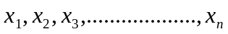 their arithmetic mean, denoted by, can be expressed as:
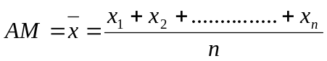
Or 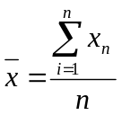
Arithmetic Mean of Group Data

If 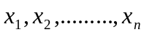are the mid-values and 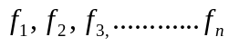 are the corresponding frequencies, where the subscript ‘n’ stands for the number of classes, then the mean is
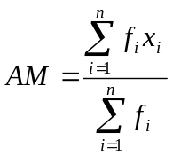
Find the Arithmetic (group data).
Class | Frequency  (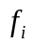) |  | 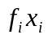 | 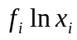 | 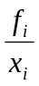
20-29 | 3 | 24.5 | 73.5 | 4.17 | .12
30-39 | 5 | 34.5 | 172.5 | 7.69 | .15
40-49 | 20 | 44.5 | 890 | 32.97 | .45
50-59 | 10 | 54.5 | 545 | 17.37 | .18
60-69 | 5 | 64.5 | 322.5 | 9.05 | .08
Sum | N=43 |  | 2003.5 | 71.24 | .98

=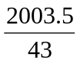=46.59

Geometric Mean

Geometric mean is defined as the positive root of the product of observations. Symbolically,
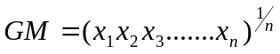

It is also often used for a set of numbers whose values are meant to be multiplied together or are exponential in nature, such as data on the growth of the human population or interest rates of a financial investment.

Geometric Mean (Revised Eqn.)

Ungroup Data 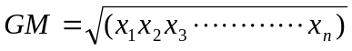
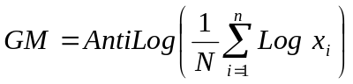
Example: The return on investment by X company for four successive years was: 30percen, 20 percent,-40 percent, and 200 percent. What is geometric mean rate of return of investment?

Solution: We know,
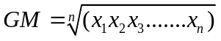
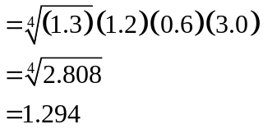
Geometric mean is =1.294-1=.294
So, the average rate of return is 29.4 %.

Uses and Limitations:
The geometric mean is typically used to find the averages percent increase in sales, production, population or other economic or business data.
But compare to arithmetic mean this average is more difficult to compute and interpret. In geometric mean all values must be positive.

Problem:
The percent increase in sales for 4 years were: 4.91, 5.75, 8.12 and 21.60.
Find arithmetic and geometric mean percent increase.

Solution: We know,

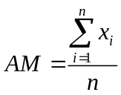=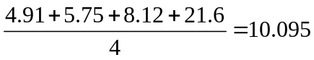
So, Arithmetic mean 10.095 percent increase.

=
GM=1.099-1=.099
Geometric mean 9.9 percent increase.

Harmonic Mean

Harmonic mean is one of several kinds of average.

Typically, it is appropriate for situations when the average of rates is desired. The harmonic mean is the number of variables divided by the sum of the reciprocals of the variables. Useful for ratios such as speed (=distance/time) etc.

The harmonic mean H of the positive real numbers 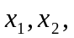…….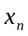 is defined to be

Ungroup Data 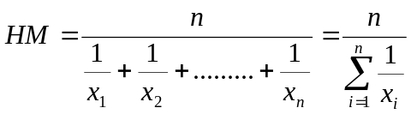
Example: A car travels 50 miles at 40 mph, 60miles at 50mph and 40 miles at 60mph.What is the average speed of the trip?
Sol: The distance is 50 miles, 60miles and 40 miles.
We know, 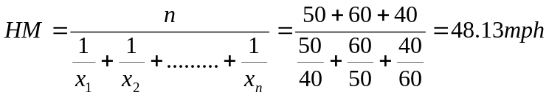
Uses and Limitations:
The harmonic mean is typically used to find the averages of rates.HM also less effected mean for extreme values.
However, harmonic mean cannot be computed one or more observations have zero value.

Weighted Mean

The Weighted mean of the positive real numbers 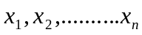with their weight 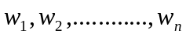is defined to be 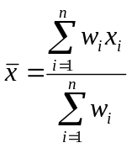.

Example: During a one hour period on a hot Saturday afternoon cabana boy Chris served fifty drinks. He sold five drinks for $0.50, fifteen for $0.75, fifteen for $0.90, and fifteen for $1.10. Compute the weighted mean of the price of the drinks.

Sol: 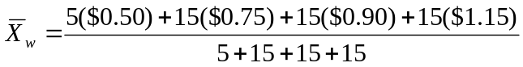
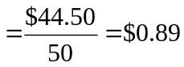

Median
The Median is the midpoint of the values after they have been ordered from the smallest to the largest or from the largest to the smallest. The implication of this definition is that a median is the middle value of the observations such that the number of observations above it is equal to the number of observations below it.

Median of Ungroup Data

If “n” is odd 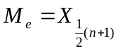
If “n” is Even 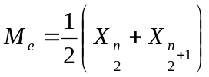
Median of Group Data 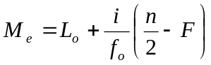
- 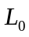 = Lower class boundary of the median Class
- i = Width of the median class/class interval.
- 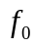 = Frequency of the median class
-  = Cumulative frequency of the pre-median class

Steps to find Median of group data

- Compute the less than type cumulative frequencies.
- Determine 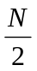 ,one-half of the total number of cases.
- Locate the median class for which the cumulative frequency is more than
- Determine the lower limit of the median class. This is.
- Sum the frequencies of all classes prior to the median class. This is F.
- Determine the frequency of the median class. This is.
- Determine the class interval of the median class. This is i.

Example (for ungroup data):
Ex-1:
The ages for a sample of five college students are:
21, 25, 19, 20, 22. Find median.

Sol: Arranging the data in ascending order gives:
19, 20, 21, 22, 25.
Thus the median is 21.

Ex-2: The heights of four basketball players, in inches, are: 76, 73, 80, 75.
Arranging the data in ascending order gives:

73, 75, 76, 80
Thus the median is 75.5.

Find Median (for group data)

Age in years | Number of births | Cumulative number of births
14.5-19.5 | 677 | 677
19.5-24.5 | 1908 | 2585
24.5-29.5 | 1737 | 4332
29.5-34.5 | 1040 | 5362
34.5-39.5 | 294 | 5656
39.5-44.5 | 91 | 5747
44.5-49.5 | 16 | 5763
All ages | 5763 | -

, here n=5763
=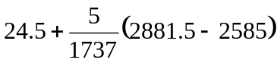=25.35

Mode

Mode is the value of a distribution for which the frequency is maximum. In other words, mode is the value of a variable, which occurs with the highest frequency.

Data can have more than one mode. If it has two modes, it is referred to as bimodal, three modes, tri-modal, and the like.

Example (ungroup data): The exam scores for ten students are: 81, 93, 84, 75, 68, 87, 81, 75, 81, 87.calculate mode
Sol: Because the score of 81 occurs the most often, it is the mode.

Ex-2: The list (1, 2, 2, 3, 3, 5) has the two modes 2 and 3.

Mode of Group Data

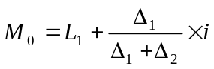

-  = Lower boundary of modal class
- 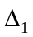= difference of frequency between modal class and class before it
- 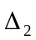= difference of frequency between modal class and class after
- i = class interval

Steps of Finding Mode

- Find the modal class which has highest frequency
- = Lower class boundary of modal class
- = Interval of modal class
- = difference of frequency of modal class and class before modal class
- = difference of frequency of modal class and class after modal class

Example: Find Mode (group data)

Slope Angle (°) | Frequency (f)
0-4 | 6
5-9 | 12
10-14 | 7
15-19 | 5
20-24 | 0

=5+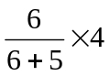
=7.18

Example: Find Mean, Median and Mode of Ungroup Data

The weekly pocket money for 9 first year pupils was found to be: 3 , 12 , 4 , 6 , 1 , 4 , 2 , 5 , 8

Mean-5
Median-4
Mode-4

